Ancient Religions: Year 11
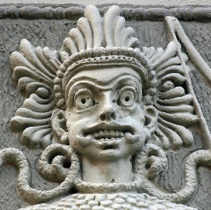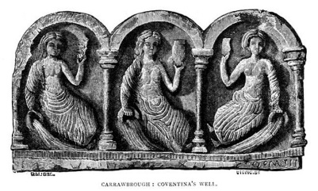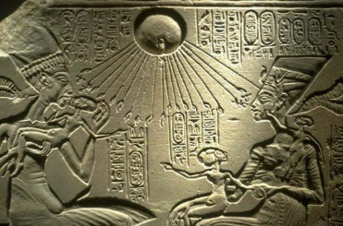
Note: Wikipedia has excellent reliable information for this topic
Britannica Encyclopaedia, also excellent, can also be accessed through the Simon page, under student links

General site which covers most religions.
http://www.ancient.eu/religion/
Link to Ancient texts & timelines: not a complete factual list but indicative
http://www.sacred-texts.com/time/timeline.htm
https://metalgaia.files.wordpress.com/2015/04/timeline-myth-religion.jpg

Babylonian
http://www.bible-history.com/babylonia/BabyloniaReligion.htm

Ancient Babylonia - Religion - Bible History Online

https://en.wikipedia.org/wiki/Babylonian_religion
http://i-cias.com/e.o/bab-ass_rl.htm

Egyptian
Religion in the lives of the ancient Egyptians
http://fathom.lib.uchicago.edu/1/777777190168/
Describes the origin and nature of the Egyptian gods, the cult of the gods, the importance of Maat, the king and Osiris, etc.
Religion and politics in ancient Egypt
http://www.scihub.org/AJSMS/PDF/2012/3/AJSMS-3-3-93-98.pdf
The mythology and cultus of the Sun-God, the apotheosis of the Pharaoh and the cult of the dead in ancient Egyptian society.

Mayan
http://www.ancient.eu/Maya_Religion/
http://anthropology.msu.edu/anp264-ss13/2013/04/24/mayans-religion-gods-animal-spirits-and-pyramids/
https://en.wikipedia.org/wiki/Maya_religion
Mayan Religion fast facts and introduction
http://www.religionfacts.com/mayan-religion
Cosmology and Religion.
http://www.historymuseum.ca/cmc/exhibitions/civil/maya/mmc03eng.shtml
Sumerian
https://en.wikipedia.org/wiki/Sumerian_religion
http://realhistoryww.com/world_history/ancient/Misc/Sumer/Sumerian_Religion.htm
http://i-cias.com/e.o/sumer.religion.htm

Celtic : Britannica
Good intro in Britannica : access here or through Simon
http://school.eb.com/levels/high/article/Celtic-religion/damascuscoll
Good basic info:
http://celticreligion11094.weebly.com/
http://celticrelgion.weebly.com/
Ancient Rome
Ancient Rome
http://www.ancient.eu/Roman_Religion/
http://ic.galegroup.com/ic/celtic

Canaanite

https://en.wikipedia.org/wiki/Ancient_Canaanite_religion

https://www.thattheworldmayknow.com/fertility-cults-of-canaan

Ancient Greece
http://www.ancient.eu/Greek_Religion/

http://quatr.us/greeks/religion/greekrelig.htm

