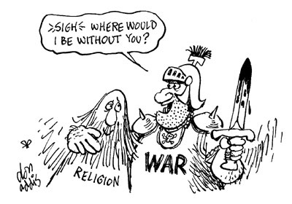
http://fryeblog.blog.lib.mcmaster.ca/category/secular-society/ (downloaded 18 September 2013)

With reference to the cartoon, explain why religious traditions may be confronted by contemporary challenges (5 marks)

