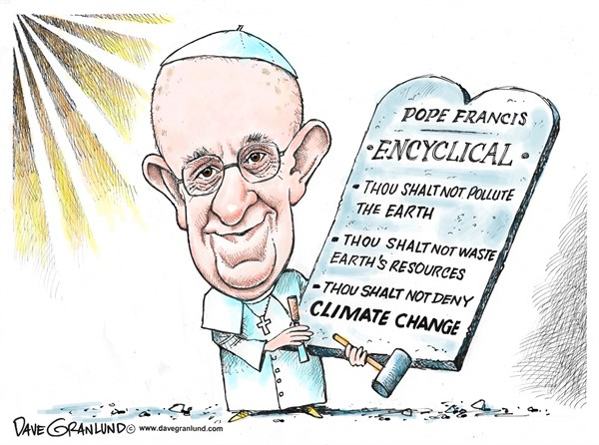

By referring to this cartoon, evaluate the impact of the response of the Catholic Church to the ecological crisis for itself and for its relationship with society (4 + 4 marks)

