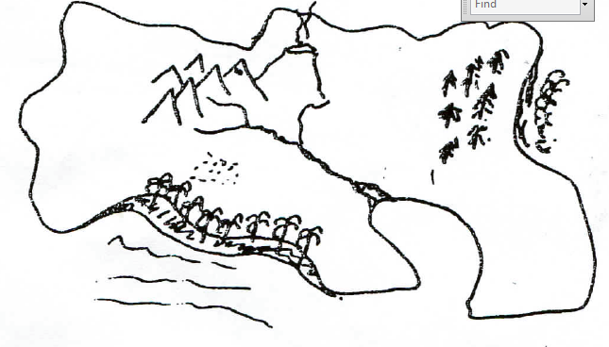
ME AS AN ISLAND

Part A
On an A3 size sheet of paper draw a map of an island that will represent something about you. Even the shape of the island has meaning as does each feature that you place on it.

Mountains, forests, rivers, volcanos, sandy beaches, rocky outcrops, caves, quicksand, plains, delta, safe harbour, cliff face, wild surf, ....

After you have given shape to your island’s physical geography, consider its inhabitants. What creatures and institutions are a part of your island?

People, cities, wild animals, insects, birds, schools, cemeteries, home ...

Be creative, colourful and proud of your island

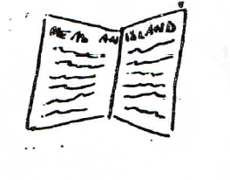

Part B

Place the heading ME AS AN ISLAND
And do the following:

So you’ve drawn your island. Now it is time to the tale, to relate the story of you as an island.

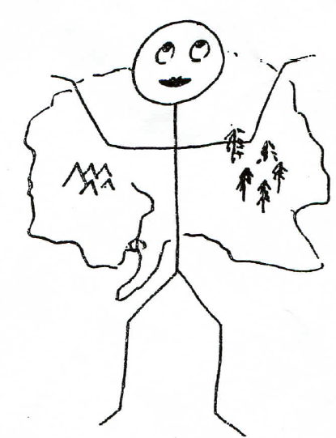
Write a reflective piece that describes in detail the meaning of the features on your island.

What does each of the geographical feature mean to you? How have you really experienced these things in your life?

What are the cities, people and animals representing in our life? What experiences in your life do these reflect?

The reflection should be about 2 pages in length and personal. Tell me about yourself for goodness sake. But only what you are comfortable telling.

