Written Response to Indigenous Rites

Task: Provide a 300 word response on one of the options under spirituality, kinship or significant sites.

Spirituality.
It has been said that…’the land to indigenous people is the core of their spirituality. This relationship to country is of essential importance to our people’.
In what ways is land essential to indigenous Australians, in particular how it is ‘their past, present and future?’
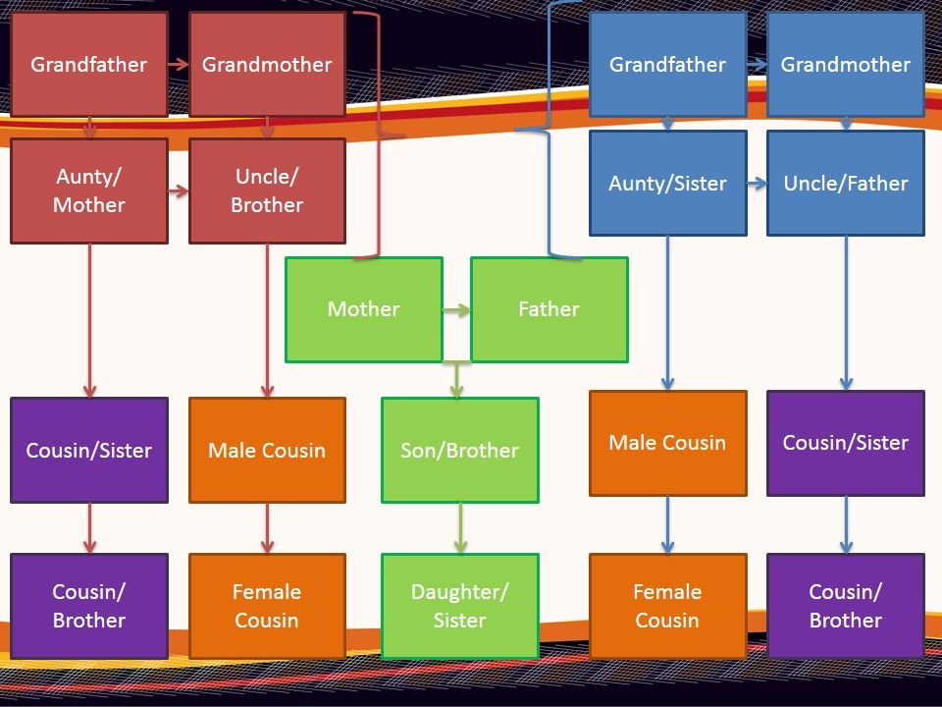
Kinship.
Kinship systems refer to how a person relates to their community and brings people together in relationships of sharing and mutual obligation. It has been described through a complex series of relationships in the following slide
Describe how this system of Kinship operates within the realms of an indigenous community. In some respects this is not dissimilar to how our families operate, yet the responsibilities here to be far greater. How does this system ensure a far greater sense of community and family support?
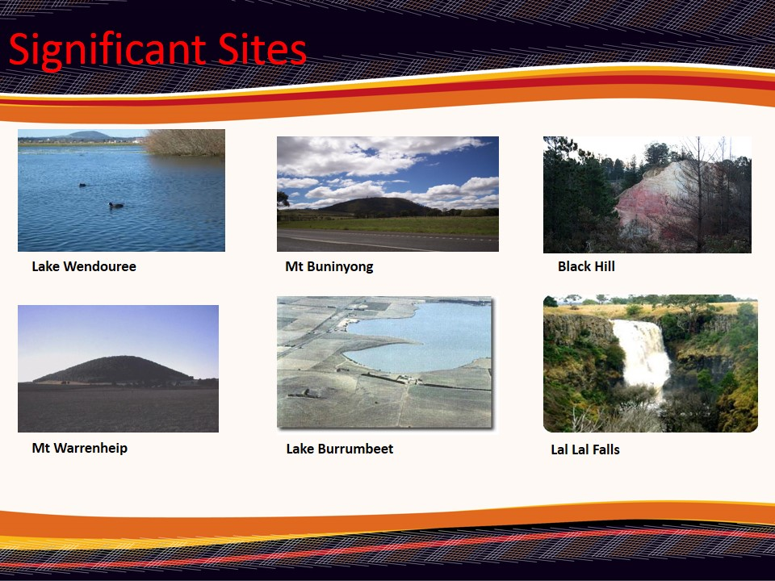
Significant Sites.
Linked to Spirituality, there are a number of significant sites of the Wathaurong people. Describe the significance of local sites shown opposite. How do these sites become a crucial element within in the concept of Aboriginal spirituality?

